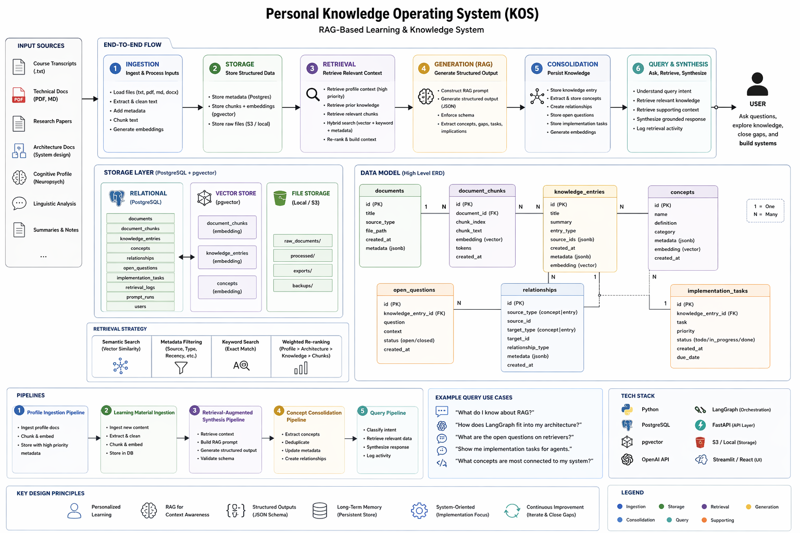

This system replaces traditional note-taking with an AI-powered knowledge system designed to make learning structured, cumulative, and directly useful. Instead of manually writing notes, I input learning material such as course transcripts, technical documents, or research papers, along with context about how I think and what I am trying to build. The system processes that information and automatically extracts the most important ideas, tailors explanations to my learning style, connects new concepts to what I already know, and identifies areas where my understanding is incomplete. Rather than producing generic notes, it generates structured outputs that are optimized for how I learn and for the systems I am building, such as an investing AI workflow.
At a high level, the system works by taking in raw information, understanding it, personalizing it, and then storing it in a structured way. When new material is added, the system does not treat it in isolation. It actively connects it to prior knowledge, determines where it fits within a broader system, and highlights what is new versus what is already understood. This creates continuity across learning instead of fragmentation. The outputs are not just summaries, but organized knowledge that includes key concepts, why they matter, how they apply in practice, and what questions remain unanswered.
All of this information is stored in a way that makes it easy to retrieve and reuse later. Instead of having scattered notes across documents, everything is organized into a searchable knowledge base. This allows me to ask questions like what I know about a specific concept, how different ideas connect, or what gaps still exist in my understanding. The system retrieves relevant information from everything I have previously learned, synthesizes it, and provides a clear, grounded response. Over time, it becomes a persistent memory system that builds on itself, rather than a collection of disconnected notes.
From a business perspective, the value comes from improved learning efficiency, retention, and decision-making. It reduces the time spent on manual note-taking, ensures that knowledge is not lost, and makes it easier to apply what has been learned to real-world problems. Because it continuously connects ideas and highlights gaps, it supports deeper understanding and more effective system design. Instead of repeatedly relearning information or struggling to recall past material, I can rely on a structured knowledge system that evolves as I learn.
The key shift this system introduces is moving from learning as passive information consumption to learning as active knowledge construction. Most people accumulate information without a system to organize or apply it. This approach builds a structured, searchable knowledge base that functions more like a personal internal Wikipedia, continuously updated and connected. Unlike standalone AI tools that provide answers in isolation, this system retains and builds on prior learning, making it increasingly valuable over time. In simple terms, it turns everything I learn into organized, retrievable knowledge that directly supports building complex systems and making better decisions.

